Henrietta Batson
CS-255 Collecting Customer Requirements
Project 1
10/3/26

CS 255 Business Requirements Document Template

Complete this template by replacing the bracketed text with the relevant information.

This template lays out all the different sections that you need to complete for Project One. Each section has guiding questions to prompt your thinking. These questions are meant to guide your initial responses to each area. You are encouraged to go beyond these questions using what you have learned in your readings. You will need to continually reference the interview transcript as you work to make sure that you are addressing your client’s needs. There is no required length for the final document. Instead, the goal is to complete each section based on your client’s needs.

Tip: You should respond in a bulleted list for each section. This will make your thoughts easier to reference when you move into the design phase for Project Two. One starter bullet has been provided for you in each section, but you will need to add more.

System Components and Design

Purpose
What is the purpose of this project? Who is the client and what do they want their system to be able to do?
- The Client: The system is for a company called DriverPass, owned by Liam, with Ian helping as the IT person.
- The Big Problem: Too many people are failing their driving tests at the DMV because they don't have good ways to practice.
- What it Needs to Do: The platform needs to let customers take online classes, practice mock tests, and book behind-the-wheel driving lessons.
- Company Size: The system has to organize a business that currently has 10 cars and 10 driving instructors.

System Background
What does DriverPass want the system to do? What is the problem they want to fix? What are the different components needed for this system?
- No Double Data: The system needs to run online in the cloud so that data doesn't get messed up or duplicated when people try to change things offline.
- Working from Home: Liam needs to be able to download reports and info so he can view them and work on them using Excel at home.
- The Three Packages: The database needs to handle three options: Package 1 (6 hours driving), Package 2 (8 hours driving + rules class), and Package 3 (12 hours driving + rules class + online practice tests).
- Smart Matching: The system has to track which student is paired up with which specific driver, car, and time slot so nothing gets mixed up.
- DMV Updates: The software needs to connect to the DMV website to get automatic alerts whenever driving rules or test questions change.

Objectives and Goals
What should this system be able to do when it is completed? What measurable tasks need to be included in the system design to achieve this?
- Turn Off Packages: Liam needs an easy button to turn off or hide specific packages so new clients can't sign up for them if they are full.
- Do-It-Yourself Booking: Students need to be able to log in, make a profile, and book, change, or cancel their own driving lessons online.
- Office Help: The office secretary needs a screen to easily register people over the phone, type in their credit card info, and set up matching pickup and drop-off spots.
- Forgot Password Fix: If a customer forgets their password, the system needs to let them reset it automatically without needing to call the company.
- Dashboard Look: The student screen should look like Liam's drawing, showing their test progress (Not Taken, In Progress, Failed, Passed) and notes left by the instructor.

Requirements

Nonfunctional Requirements
In this section, you will detail the different nonfunctional requirements for the DriverPass system. You will need to think about the different things that the system needs to function properly.

Performance Requirements
What environments (web-based, application, etc.) does this system need to run in? How fast should the system run? How often should the system be updated?
- Where it Runs: It must be a website that runs out of the cloud.
- Speed: It needs to load quickly so the secretary isn't stuck waiting while on the phone with a customer.
- Updates: The system should update instantly when the DMV pushes out new info.

Platform Constraints
What platforms (Windows, Unix, etc.) should the system run on? Does the back end require any tools, such as a database, to support this application?
- Devices: It needs to work on any normal web browser on both computers and phones.
- Back-End: It needs a solid online database to keep all the records in one safe place.
- File Types: It must let Liam export his weekly business reports into standard Excel files.

Accuracy and Precision
How will you distinguish between different users? Is the input case-sensitive? When should the system inform the admin of a problem?
- User Types: The system must recognize who is logging in (Liam the boss, Ian the IT guy, the secretary, or a student) and give them the right screen.
- Good Data Entry: The sign-up forms need to make sure things like credit card numbers and addresses are typed in correctly.
- Tracking: The system needs to keep an exact record of who made, changed, or canceled a lesson slot.

Adaptability
Can you make changes to the user (add/remove/modify) without changing code? How will the system adapt to platform updates? What type of access does the IT admin need?
- Easy Staff Management: Ian needs a way to add new employees or block old employees without having to rewrite the software code.
- Changing Packages: The owner should be able to update what is included in the driving packages without needing a programmer.
- No Technical Drama: The system should handle its own security and background backups in the cloud so the company doesn't have to fix technical glitches.

Security
What is required for the user to log in? How can you secure the connection or the data exchange between the client and the server? What should happen to the account if there is a “brute force” hacking attempt? What happens if the user forgets their password?
- Logging In: Users must have a unique username and password to log into their accounts.
- Hacker Protection: If someone tries to guess a password over and over (a hacking attempt), the system should lock the account or sound an alarm.
- Master Key: Ian needs full admin access to override passwords or instantly shut down an account if someone is fired.

Functional Requirements
Using the information from the scenario, think about the different functions the system needs to provide. Each of your bullets should start with “The system shall . . .” For example, one functional requirement might be, “The system shall validate user credentials when logging in.”
- The system shall check if a user's password is correct when they log in.
- The system shall print out a report showing exactly who changed a lesson reservation.
- The system shall limit all driving lessons to exactly two hours long.
- The system shall block a car or a driver from being booked for two different lessons at the same time.
- The system shall label practice test results as Not Taken, In Progress, Failed, or Passed.
- The system shall show a pop-up alert whenever the DMV sends an update.

User Interface
What are the needs of the interface? Who are the different users for this interface? What will each user need to be able to do through the interface? How will the user interact with the interface (mobile, browser, etc.)?
- The website must change size cleanly to look good on both wide desktop screens and small mobile phones.
- The student page layout must match Liam's sketch, with boxes for test scores, personal info, teacher notes, special needs, and photos.
- The interface needs simple forms for the secretary or students to type in names, phone numbers, and payment details.

Assumptions
What things were not specifically addressed in your design above? What assumptions are you making in your design about the users or the technology they have?
- We assume that students have internet access at home or on their phones to use the site.
- We assume users have a normal, modern web browser to access the cloud platform.
- We assume the cloud hosting company will take care of keeping the server safe and running.

Limitations
Any system you build will naturally have limitations. What limitations do you see in your system design? What limitations do you have as far as resources, time, budget, or technology?
- Users cannot add or change reservations if they are offline, because it will mess up the master calendar.
- Regular workers cannot build new parts of the website; they can only click the settings pre-built for them.
- The company can only schedule up to 10 lessons at the exact same time because they only own 10 cars and have 10 drivers.

Gantt Chart
Please include a screenshot of the GANTT chart that you created with Lucidchart. Be sure to check that it meets the plan described by the characters in the interview.

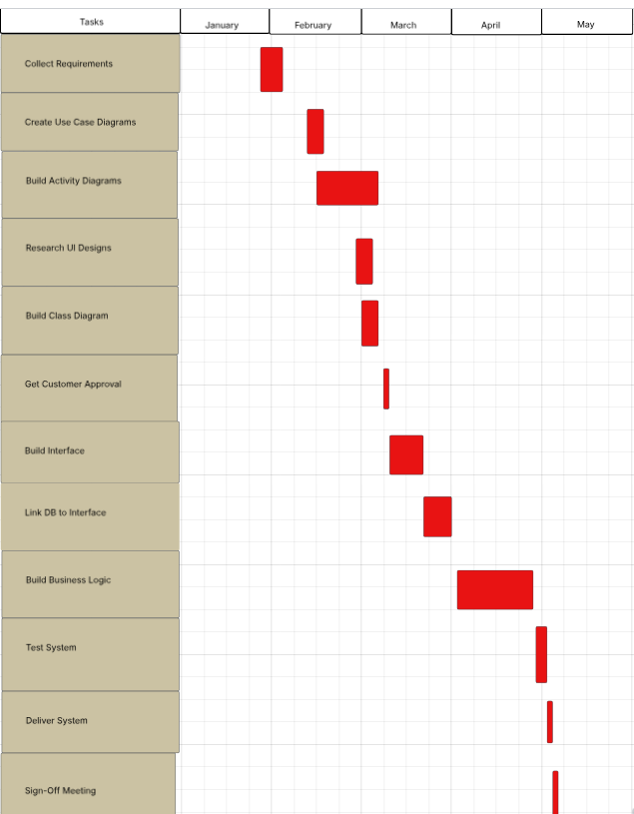

References

Southern New Hampshire University. (2026). DriverPass project interview transcript: Liam and Ian [Course material]. IT-CS 255: Systems Analysis and Design.

Valacich, J., & George, J. (2025). Modern Systems Analysis and Design (10th ed.). Pearson.

